Microstation Thoughts November 2016
The idea for microstations - tiny coffee washing stations which are constructed, owned and operated by small groups of farmers - came from several sources and times.

- During a visit to Peru (COCLA) in 2001 the author, Andy Carlton, saw a "beneficio humido" on every coffee farm visited - tiny coffee washing stations complete with fermentation tanks, washing channels and drying patios. I'd never seen this in Africa and had not realised you could do full wet coffee processing at the level of the individual farm. I was used to the typical farm-washed coffee of African farmers, poor cherry harvesting, inconsistent fermentation, incomplete washing, no grading, drying on tarpaulins or even on dirt, storage together with anything and everything... The Peruvian experience did not result in any immediate light-bulb since farms in Peru are much bigger than in Africa and I did not see how the method would work on very small farms. But it stayed in my mind.

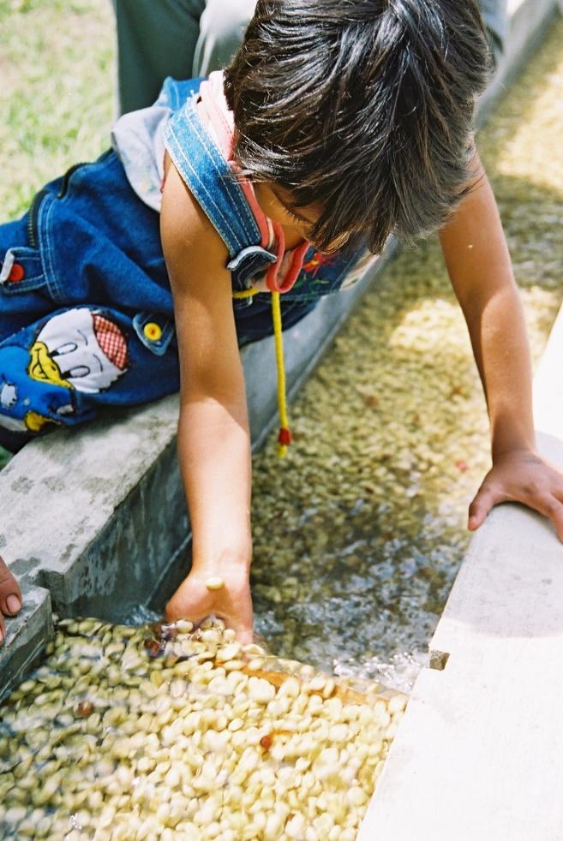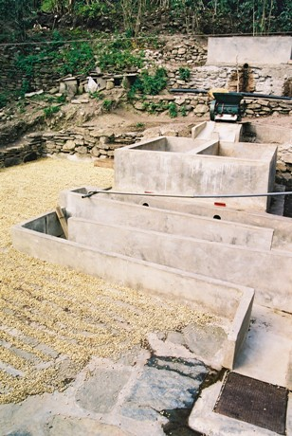
Beneficios of individual farmers at Huadquina and Limonpata, Quillabamba, Peru, Sept 2001

- Between 2004 and 2007 I worked in Rwanda advising a Twin (IFAD-funded) project which built a number of standard washing stations (100 to 150 tonnes of parchment per season) and a couple of mini-stations (30-50 tonnes). These washing stations were 100% debt-financed and when the debt was paid off would be 100% owned by the co-operative. This experience considerably deepened my technical understanding of washing coffee, but it also showed some of the drawbacks of large washing stations, particularly the difficulty of making the washing station pay when debt-financed. Since this was a government project the bank did not foreclose on any of the project loans; but it took, for example, Kopakama Co-operative 10 years to pay off a loan which was supposed to take 3 years. Interest payments were therefore far more than originally budgeted. What the project did demonstrate conclusively is that washing coffee centrally adds significant value, permanently, always provided that the intrinsic quality of the coffee is excellent and that farm-washing has failed to maximise that quality. Both of these conditions obtained in Rwanda.

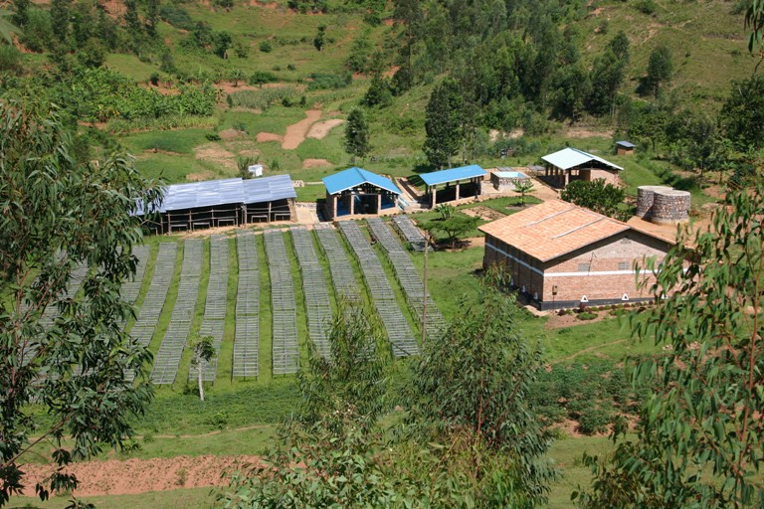
Koakaka Co-operative, Rwanda. Standard washing station at Karambi.

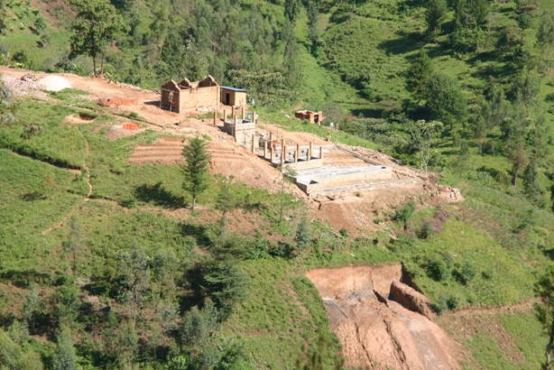
Abakundakawa Co-operative, Rwanda. Minazi mini-station under construction

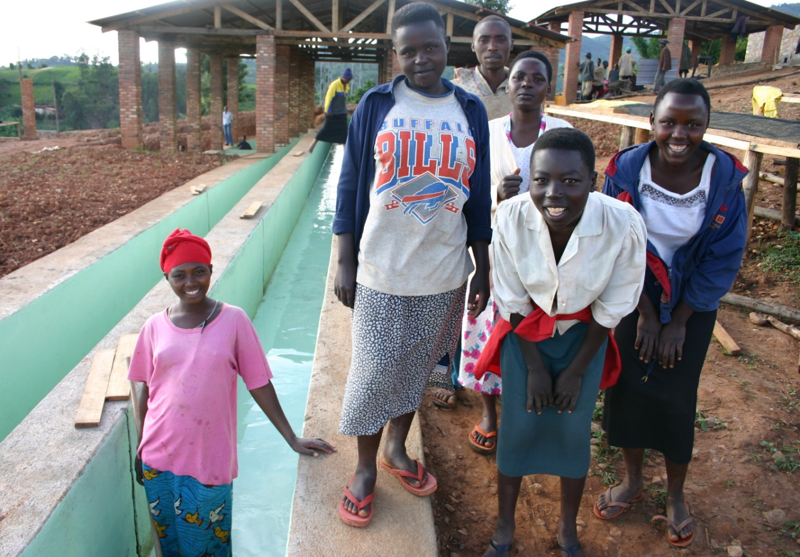
Kopakama Co-operative, Rwanda. Workers at Mushabati washing station.

- In 2008 I visited Mzuzu Coffee in Malawi for the first time. The model at Mzuzu was that the union built each mini-washing station using EU funding (there were 45 zones, each with its own mini-station with between 50 and 200 farmers) but the members operated the station themselves on a voluntary labour basis. This was the first time I'd come across this arrangement. The stations were smaller than those in Rwanda, but some of them were doing significant volumes of coffee. The funding model was not replicable, EU funding was available in Malawi much more readily than in East Africa due to Malawi's status as one of the world's poorest countries. But the voluntary labour component, reducing the fixed costs of operations, would be interesting if it was possible to replicate that elsewhere. Also in Malawi I saw for the first time local materials used for washing station construction, reducing the capital cost of construction.

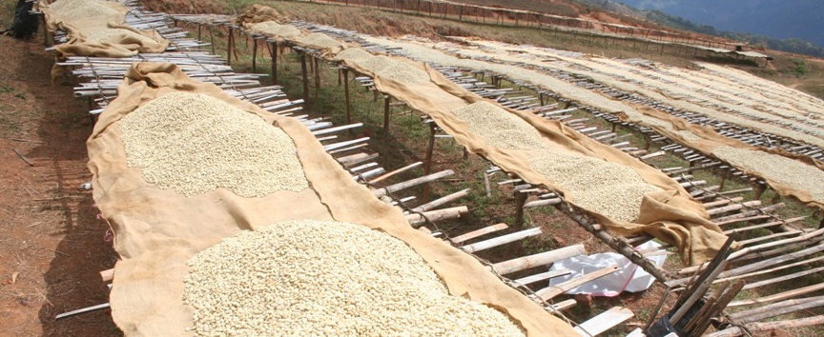
Misuku Co-operative, Mzuzu Coffee Co-op Union. Drying tables at Chanya zone made from local materials.
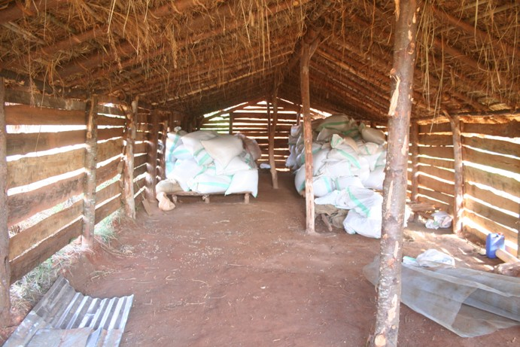
Chanya zone coffee store - ventilated timber and thatch, mud floor with wooden pallets.

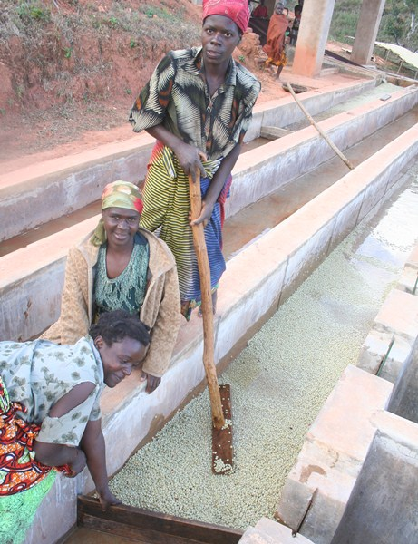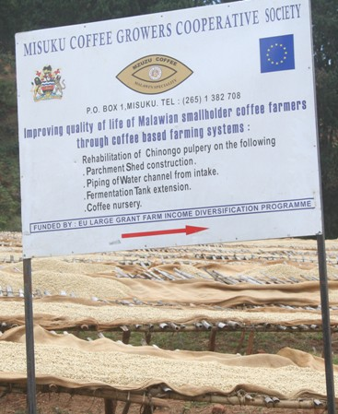
The very first women's coffee at Mzuzu, from Twishima women's business centre, Ndoropa zone, Misuku Co-operative; and the regionally non-replicable EU project funding for washing station development in Malawi.

- I visited Rwenzori in western Uganda for the first time in January 2010, and with difficulty climbed the dizzying hillside paths to visit farmers. Bukonzo Joint and Bukonzo Organics both wanted to do better coffee business. Their members were drying coffee cherry on the ground to produce "kiboko", paying for it to be hulled locally in commercially-operated multi-purpose hullers, and selling it to middlemen at prices well below those obtained by Gumutindo farmers, who were farm-washing their coffee on the other side of the country. The farmers in Rwenzori seemed to be ignorant of the local price difference between farm-washed parchment and hulled "natural" FAQ coffee. I had several conversations in which both farmers and local NGO staff told me that the price was "the same". It was the same per kg, but 20% of parchment is husk, so the price for parchment was actually 20% higher than for clean "natural" FAQ, for the same weight of green coffee. This took some explaining, but it became clear that even without adding any more value it would make sense to stop drying cherry and start washing parchment. But the terrain was tough, very steep and difficult. You couldn't start carrying fresh cherry on your back down the mountain to a big washing station, it would be too heavy. Donkeys are non-existent in Rwenzori, for some reason. There were very few pulpers available, so the idea of washing the coffee in Rwenzori stalled for a while.

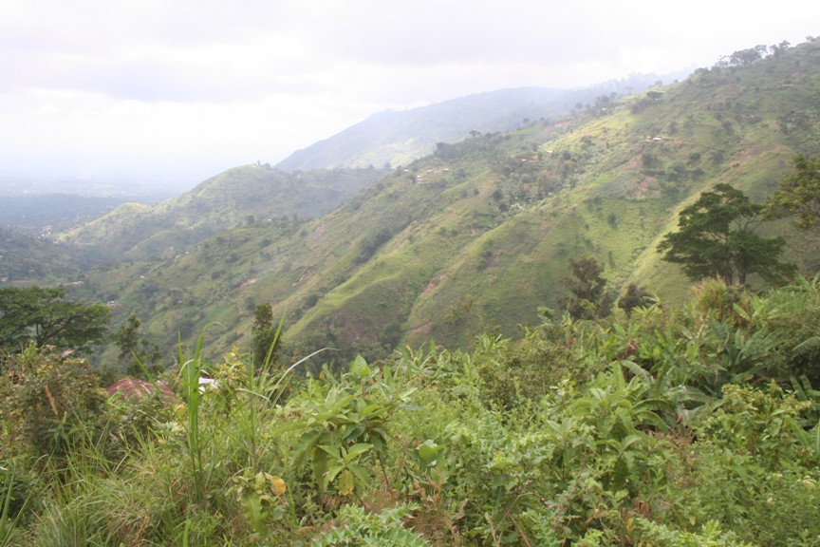
Rwenzori. The coffee is at the top, the roads are at the bottom. Very taxing to carry heavy fresh cherry coffee down those slopes every day. Better to wash it as near as possible to the farm, but centrally nevertheless, for consistent high quality.

- In February 2011 Twin sent me to find out what was happening at Co-operative Permata Gayo in Aceh Province, northern Sumatra, Indonesia, following a bad season in which the co-operative had defaulted on several contracts due to unaffordable local coffee prices in 2010. I was amazed to discover that the fairtrade-certified farmers in each village elected a local self-employed "collector", who went to each farm and bought the coffee cherry from the farmer at a price fixed by the co-operative, then processed it himself (it was always a man) on a tiny washing station on his own farm, (similar to the humid beneficios I'd seen in Peru ten years earlier, but without a washing channel), then sold the wet parchment back to the co-operative, again at a price fixed by the co-operative, making his business margin between the two prices. The farmer trust in the collectors was deep. The farmers left their cherry coffee in sacks outside their houses and the collector or his agent picked them up on a motorbike without the owner being present. I can't imagine that in East Africa.

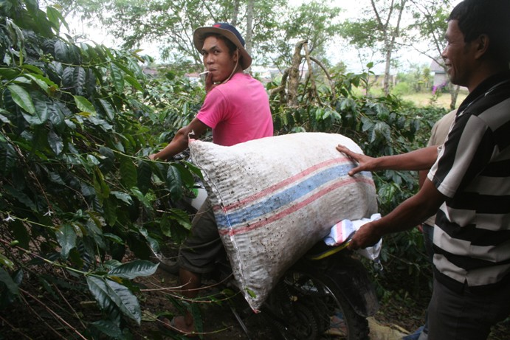
Collector's agent picks up a sack of cherry from a farm where the farmer was not present. All the men smoke all the time. The local name of the ubiquitous shade trees is "Lamtoro", (Lucaena lucocephora)

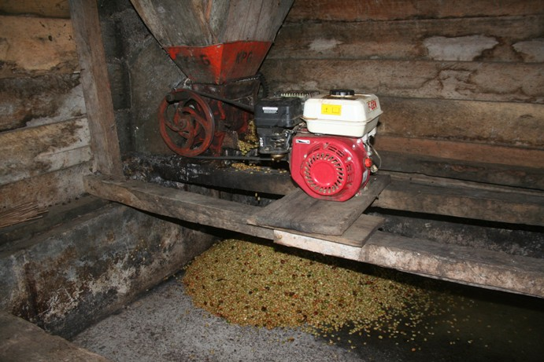
Small "Baby Bentall" type drum pulper driven by a 5.5HP Honda petrol engine, mounted over a fermentation tank.
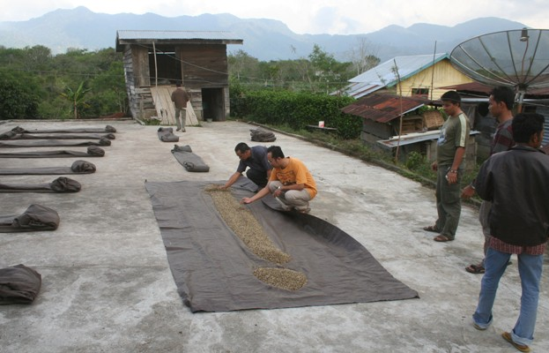
Patio and pulping/fermenting house at one of the Permata Gayo collector's houses. Pulping, fermenting and a quick preliminary drying, no washing or grading. Every house in the village has a satellite dish and at least one motorbike. Farmers earn an (estimated) average of USD 10,000 per year from their coffee. In East Africa (outside of Kenya) it is closer to USD 500.

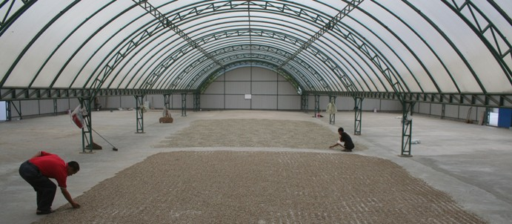
At Permata Gayo the beautiful drying tunnels are owned by the exporter, not the co-operative. But the idea of drying under plastic, something I had never seen until then, is brilliant, and copy-able at a smaller scale.

Suddenly, there was the model for the micro-station. A tiny wet-processing factory in the middle of the village, with drying under cover. Even smaller than the Mzuzu zone model. In Sumatra the wet parchment is sold by the collector to the co-operative after only a day or two of patio drying, so the need for drying space is limited. The co-op then hulls the parchment while it is still wet, and dries it first as "labo" (from 40% down) then as "asalan" (below 20%). In East Africa we would need more drying capacity, especially because the harvest season is also the rainy season, unlike lucky Mzuzu.
[An aside: in East Africa we have never tried to copy Sumatra, to hull the parchment when it is still wet and dry it as green coffee. The specialty coffee people tell us that you must never hull the parchment till you are ready to ship or it will lose quality. Yet in Sumatra their coffee tastes of oiled earth but they get much higher quality premiums than we get in Uganda. I wonder why?]

I came back from Sumatra with my head buzzing, and began to promote the microstation idea with our Ugandan partners Gumutindo and Ankole Coffee Producers Coop Union, and with our prospective partners Bukonzo Joint, Bukonzo Organics and Semliki.

- Later in 2011 I visited a cocoa wet-processing factory in Bundibugyo. At the time I was not working in cocoa but was interested to see their factory. The idea I took away from the visit was their drying sheds. Until then I had never seen coffee being dried under a roof in Africa, and only in very big expensive sheds in Sumatra. Here was another way to dry coffee that would defeat the local climate and radically reduce the need for labour on the station. The problem was those horribly expensive rigid plastic roof sheets, about 5 times the cost of metal.

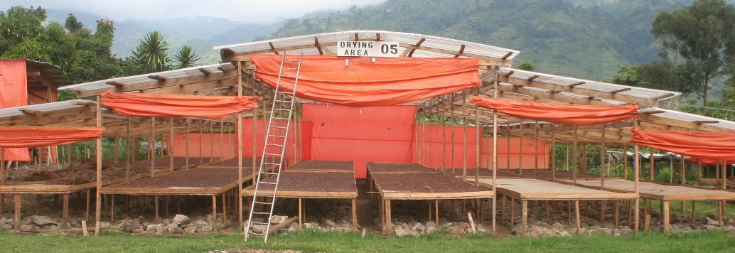
Cocoa drying shed in Bundibugyo, Uganda. The rocks under the tables are to retain and re-radiate heat through the night. We tried them but did not find them effective.

Detail of roof

Theoretical pros and cons of the model
The microstation model seemed to me to have a number of advantages:

- It had all the advantages of a conventional large washing station in terms of the potential to produce a high and consistent quality of coffee, provided that procedures were faithfully followed.
- It needed only a small amount of land, which could easily be found in each village.
- It needed a small amount of water, so location was not the critical issue it is with bigger washing stations, and waste-water disposal would not be such a headache.
- It did not need road access for a four-wheeled vehicle. The dry parchment could be ferried out on motorbikes and even on people's backs. So it could be located in inaccessible places, very near to coffee farmers.
- It was small and simple enough to be constructed by farmers themselves; it did not need a construction company and a formal contract and large amounts of money.
- It could be constructed mostly from local materials, bricks, sand, timber, stone, thatch.
- It could be constructed using member-labour on a voluntary basis, with member contributions valued and becoming the equivalent of shares in the micro-station.
- It would be within walking distance, no vehicle transport would be needed to collect and deliver to the micro-station, farmers could deliver their cherry themselves.
- It could be monitored by the farmers easily as it would be right in their midst, giving greater security and greater psychological ownership by members.
- It would be small enough that every member would be known to every other member, so any issues could be quickly addressed and resolved.
- It would genuinely empower famers, making them local economic actors, adding value to their coffee, rather than remaining in their traditional role of raw commodity price-takers.
- It would combat the intense competition from the multi-national coffee trading houses, by being easily the most convenient way the farmer could sell his/her coffee.
- All the above advantages mean that the model is replicable on a large scale, if it catches on.

- A disadvantage would be that farmers could no longer use their dry coffee as a form of savings, since they would have to sell cherry whenever it was ripe.
- Another disadvantage was realised as the idea took off, that the sheer number of micro-stations could become a headache to effectively monitor. The success of the model brought its own problems.

The quality of most fresh cherry on Rwenzori before the microstations came

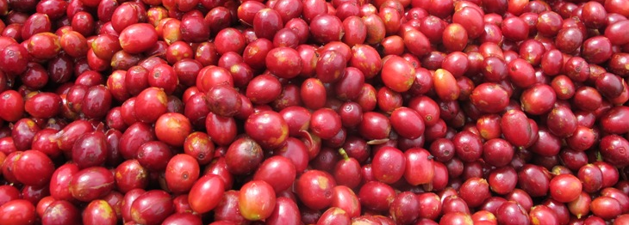
Cherry at Kothungola micro-station, Kawa Maber Co-operative, in Ituri Province, DRC, December 2015

The model - preliminary and first season activities
- a specific location is selected and research done into coffee quality, volume and processing practice to see if the project is viable there - meeting farmers and their organisations, testing coffee samples, talking to prospective buyers, meeting other stakeholders, competitors, donors, writing a scoping study
- an umbrella smallholder coffee-farmer body is approached by the project and the model is explained
- the umbrella body agrees to the microstation approach
- a project proposal is developed together with the participating umbrella body(s) and project funding is sought and gained
- farmers form small groups (from 50 to 200 members, depending on the local situation)
- each group is registered with bye-laws and is a member of the umbrella body
- each group is trained about their own responsibilities, those of the project and those of the umbrella body
- with training support, each group agrees staffing levels needed and the basis for payment to members for operating the micro station in season, and produces a basic business plan for the season
- with training support, the umbrella body produces a full business plan for the season
- each group identifies a suitable piece of land with convenient access to water and a road, and gets written permission from the owner to use the land for a period of years, or buys it
- a construction sketch and bill of quantities for the microstation is produced and explained to the group
- the group collects local materials and builds (with monitoring support) the main framework for the micro-station - coffee store, drying shed, drying tables, quality table, water storage tanks, using voluntary member labour and/or labour paid from member cash contributions
- each group member contributes labour, materials and cash, or any combination of the three; member-contributions should be as equal as is feasible, to avoid the microstation "belonging" to a small elite group of richer farmers
- member contributions are valued according to a pre-agreed scale, and individually recorded as the value of that member's shares in the microstation
- when the microstation framework is complete (not before then) the project supplies the specialist equipment - pulper, moisture meter, galvanised coffee mesh, steel security mesh, fermenting bins, cement, roof sheets (metal and plastic), solar lighting, steel door for the store, sundries, needed to finish the microstation
- key microstation personnel are selected by the group, together with the umbrella body, and are trained in microstation operations and administration
- crop and export finance is raised using the umbrella body's business plan and any buyer contracts available, and the business begins
- all aspects of microstation operations are supervised by the project during the first two seasons, to ensure that the training is embedded and the procedures are followed faithfully
- parchment coffee is collected by the umbrella body, dry-processed and sold
- the season is reviewed, learnings are identified, changes are implemented and the coming season is planned

The list is not exhaustive but covers most of the key areas.

Early experiments
Gumutindo went for the idea immediately in a big way, and spent about USD 40,000 of Fairtrade premium buying 20 Pinhalense motorised drum-pulpers and deploying them at societies in 2011. They did not perform well. It was questionable whether societies of 500 to 1,000 members were the right organising unit for micro-pulperies that could only process a small amount of coffee. The farmers had not been involved in discussing or approving the idea and were not asked to invest in it directly, so it was not something of theirs. Gumutindo never took the concept further than pulping and fermenting at society level. Gumutindo collected the fermented wet parchment from the societies, on the basis that the parchment would be dried at the HQ in Mbale town and the society paid per kg of dry parchment, as was normal practice. But the society had bought fresh cherry from its members, not dry parchment, and somewhere along the way the figures did not tally. Disputes arose, un-reconcilable debts were incurred and trust was lost between societies and union. Several of the expensive pulpers were stolen and the rest of them gradually fell into disuse, victims of Gumutindo's over-enthusiasm combined with inadequate planning and management.

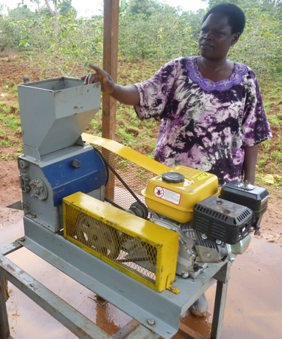
Gumutindo - Bunabude society motorised micro-pulper with Jennifer Wetaka, society chair.

Twin put together a project proposal for Rabobank, to work with 4 Ugandan partners, which included three components:

- technical assistance grant-funding in business planning, microstation construction, coffee processing and marketing the coffee to specialty buyers
- investment loan funding for micro-station construction and equipment
- working capital loan funding for operating the micro-stations - buying, processing and exporting the coffee

Rabobank funded the project over three years, starting in 2012, during which time about 60 micro-stations were constructed by the four Ugandan partners.

In 2012 I was asked to visit DRC by VECO, a Belgian NGO, and during that visit I discussed the micro-station model with VECO staff and coffee farmers. The result of this was that the model was adopted by the project, funded by the Belgian government, Cordaid and CFC; four new co-operatives were started in four different regions of eastern DRC, and they have been constructing micro-stations ever since. They currently have 98 operating between them, with 34 planned.

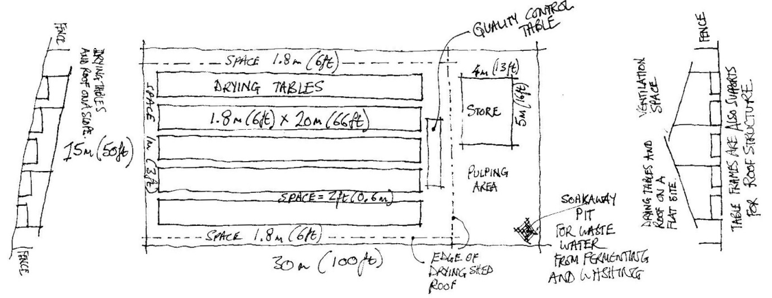
Early 5-table micro-station sketch design

The early microstations
The three earliest micro-stations in Uganda were at BOCU (Kathendegere and Kasokero) and BJCU (Mughete). They all began processing coffee in September 2011. These were the only microstations operating in 2011.

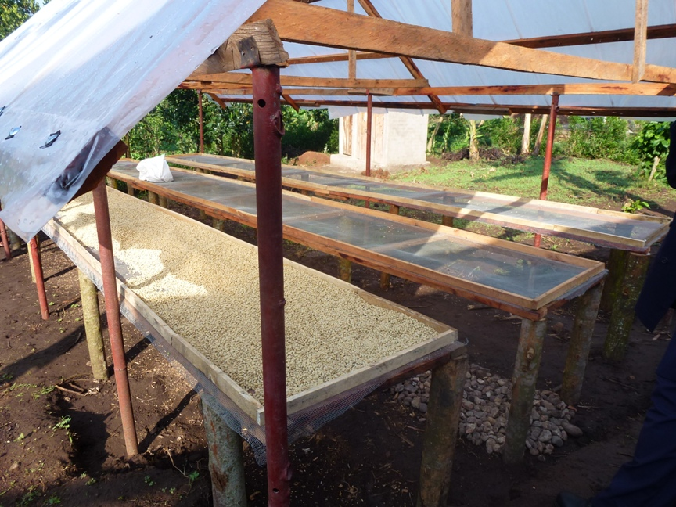
Mughete drying shed and tables. Metal poles give a more permanent structure than most microstation drying sheds.

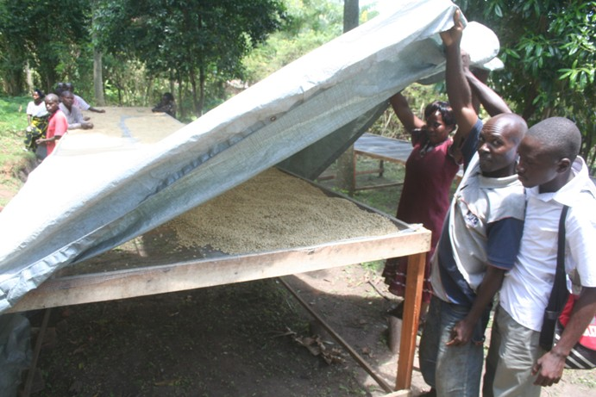
Kathendegere drying table with tarpaulin cover. They built the tables under the trees so it was not easy to put a roof over them.

There were some technical errors made in the early stages:

- We used a type of clear plastic sheeting for the roofs of the drying sheds which was not suitable and was destroyed by wind, sun and rain after one or at most two seasons. The weather in Rwenzori can be extreme and we did not design adequately for it at first.
- Early motorised pulpers did not have an engine-speed reduction gear and ran too fast, wearing out the bearings and performing poorly.

BOCU micro-station at Burangwa. The plastic roofing material was a failed experiment. Members here invested more energy and money in the store than in the drying shed - a common mistake, especially in DRC. You need a lot of space for drying but not very much for storage. But people do like permanent buildings.

The best of the early micro-stations were at Bukonzo Joint, whose members thought carefully about the design and made a number of key innovations. These included:

- using rigid metal roof sheets rather than the clear plastic sheeting used at first.
- using rigid corrugated clear plastic sheets mixed with the metal roof sheets for solar penetration - more expensive but much better than metal sheets on their own.
- Fencing the drying shed with steel security mesh to prevent theft.
- Constructing several tiers of drying table, to increase the drying capacity of the tables while reducing the area covered and therefore the cost of the roof.

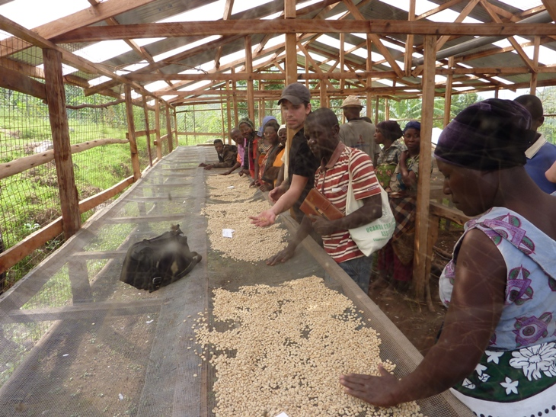
BJCU - Kitabona mini-station. The innovation of mixing metal and rigid clear plastic roof sheets and the use of steel security mesh started here, but the drying tables are still single-storey. The buyer is Tim from Counter Culture in North Carolina, USA.

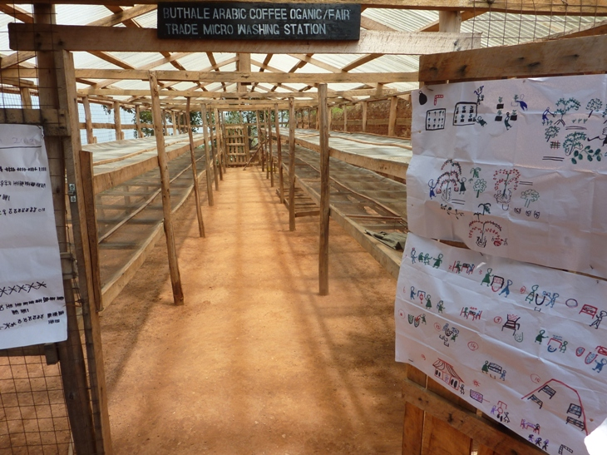
Two-tier drying tables at Buthale (BJCU). There are now many micro-stations with 3-tier tables. Another BJCU innovation is the manual - we took the BJCU GALS pictogram approach and extended it to the operating manual, so anyone who visits can see the processing stages on the micro-station. This is now almost universal.

Examples and discussion of BOCU, ACPCU, Semliki, DRC and West Nile microstations

BOCU
The management at BOCU was much less well-organised than BJCU, but the members were very willing, and constructed a large number of microstations in the first two years of the project. The major issues at BOCU were interlinked: quality of coffee, market, and low volumes. Even with very intensive support from Twin on quality training and microstation monitoring, and on marketing, BOCU could never seem to hit its quality targets, nor attract the volumes it had projected. It has taken more years than anticipated for BOCU to pay off its micro-station investment loan to Rabobank, and it is still in process of doing this. I stopped working at BJCU at the end of 2014 and I have not followed its trajectory since then, but in the 3 years 2012-14 it struggled to fill one container per season, despite having up to 23 microstations operating by the end of the period. In my opinion the reasons for this were:

- BOCU was an offshoot of Kiima Foods, a local NGO, and started with an NGO ethos, not a business ethos; it expected to survive on grant funding, not on business income, and found this expectation very difficult to shake off. Its behaviour was never very business-like, and I underestimated how difficult this would be to change. The ruling ethos of the organisation meant that its board and staff were all very similar in their outlook, not businesslike.
- BOCU location was in Kasese town. By comparison, BJCU is in Kyarumba, a trading centre up in the mountains, close to the farmers. The location made it time-consuming and expensive to monitor the farmers, and weakened farmer identification with the union. BOCU has since moved much closer to its members.
- General management, particularly on quality systems. For example, a much-needed first contract with Schluter was delivered without effective hand-sorting. For a specialty coffee business this was a horrendous mistake to make. The really discouraging thing was that BOCU staff did not seem adequately to register the problem, and were completely unable to explain what had gone wrong. Which did not inspire confidence in their ability to learn from their mistakes, or to avoid the same thing happening again.

ACPCU
ACPCU is a large, well-managed coffee business which exports high volumes of fairtrade and organic robusta coffee (in 2016, 140 FCLs). It has built this business up from nothing over the last 8 years (its first exports were in 2007-8). ACPCU arabica farmer groups (they were not member societies) built 7 microstations, and processed a small amount of coffee in them in 2012-13, which was not exported as specialty. As far as I know the microstations did not operate subsequently. In my opinion the reasons for project failure were:

- ACPCU management knew nothing about the specialty arabica business, but it was in the strategic plan 2010 that they were going to enter the business by constructing washing stations in an area of arabica coffee. The area they chose, Bunyaruguru, was far from the HQ, and was an area of "incomers", ethnically mixed, with Bakonzo, Banyarwanda, Bakyiga and Banyankole populations. It was an area where ACPCU had no links, no member societies and no previous history. The traditional area of ACPCU's robusta is almost exclusively Ankole-speaking. This made for some difficulties.
- Cotton competes strongly with coffee in Bunyaruguru. It is not an area which could be certified organic, all the coffee farmers also grow cotton and use chemicals. It is lower-lying than Rwenzori, so the coffee quality is not as good.
- ACPCU did not adequately supervise the Bunyaruguru project manager, nor did they give him enough authority. At a critical moment they took a good manager (Nicodemus) away and put him in charge of robusta organic certification, breaking continuity and relationships. The manager who replaced him was not well-known to ACPCU or to the farmers, and was not supervised effectively. The ACPCU senior management focus was never on the arabica micro-stations, it was always on double-certified robusta volumes. So, although ACPCU is a businesslike organisation, it did not apply its skills to the arabica project.
- The project never seemed to gel with the groups. The fact that they were not ACPCU member-societies cannot have helped. One microstation, KIDA, did quite well in 2012-13, but the group collapsed the following year. Total volume of parchment coffee from the 7 microstations was about 7 tonnes.

ACPCU paid off its microstation investment loan to Rabobank within the loan period from profits on robusta. It has not tried to revive the Bunyaruguru microstations since the first year. It is currently considering constructing its own standard washing station in Bunyaruguru, to be managed directly by ACPCU staff, as it still has washed arabica in its strategic plan.

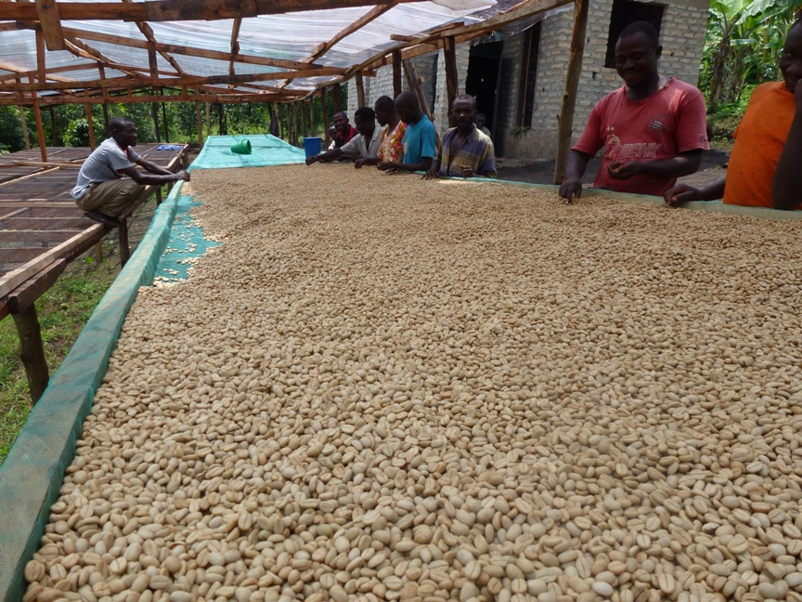
Parchment drying at KIDA microstation - ACPCU

Semliki
The worst disaster was at Semliki. This was not originally a Twin project, as Semliki was not a Twin partner. It was accepted as a Twin partner during the first year of the project, and was visited by Kat Nolte of Twin JMI in November 2012. The issue at Semliki was dishonesty. The project was actually a family set-up staged as a co-operative by a con-man, and I did not see through it, although there were clues which, with hindsight, should have made me suspicious. The farmers were real enough and they constructed a number of micro-stations. The manager bought various materials with the investment loan and distributed some but not all of them, so the microstations were never finished. He bought 12 motorised pulpers but they were not deployed at the microstations. This meant all the coffee was dried as cherry instead of being pulped, fermented and washed. This might have been interesting if done as a deliberate policy and done well. Specialty sun-dried arabica has a small but lucrative market, if it scores highly. But it was done very badly. Drying cherry takes far more space and time than drying parchment, and the microstations could not have handled the volume even if they had been finished.

Rabobank did not do sufficient due diligence and they lent too much money too soon - on my sole recommendation, which ruined my reputation with Rabobank! The members themselves did not lose out in the short term, they were paid in full for all the cherry they delivered.

Because volumes of coffee were high in unfinished microstations which had been starved of materials, (coffee mesh, roof sheeting, etc.), drying was done poorly. Fresh red cherry was left under tarpaulins when the sun was out, causing it to go mouldy. Some coffee rotted. We cupped several samples in May 2013 at a project cupping workshop run by Craig Holt of Atlas coffee, and some of it was undrinkable, stinky, vomit-inducing.

We sold one container of reasonable coffee, and the proceeds went to Rabobank to pay their loans. The remainder, 50 tonnes of clean coffee, was "stolen" from a warehouse belonging to the manager, (located literally next door to a police station), without evidence of any break-in. It was not reported to the police as a theft. Without full repayment of the working capital loan Rabobank would not advance any further finance. The business was dead. I asked the member groups to call a special general meeting to ask for an explanation from the board about the theft (members had not been informed of it). The board and manager could not give a satisfactory or convincing explanation. The meeting elected a new board. The new board suspended the manager for three months, then reinstated him without further investigation. The new board chair told the Rabobank representative (and me) that she did not believe the manager had had anything to do with the coffee theft. The theft of coffee worth perhaps USD 100,000 was never investigated by the police. I withdrew from supporting the organisation and advised Twin to withdraw, which it did. Rabobank wrote the debt off, (and wrote me off as their advisor too).

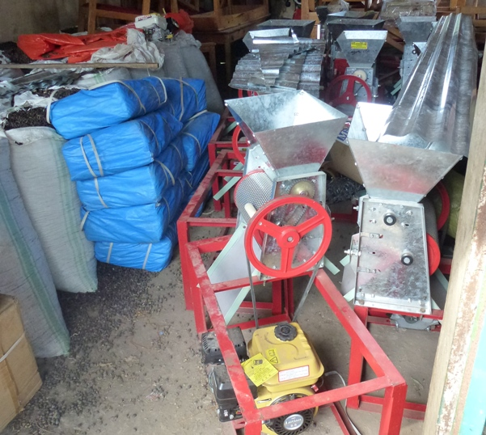
Semliki microstation supplies. The motorised pulpers were never deployed, causing a quality disaster.
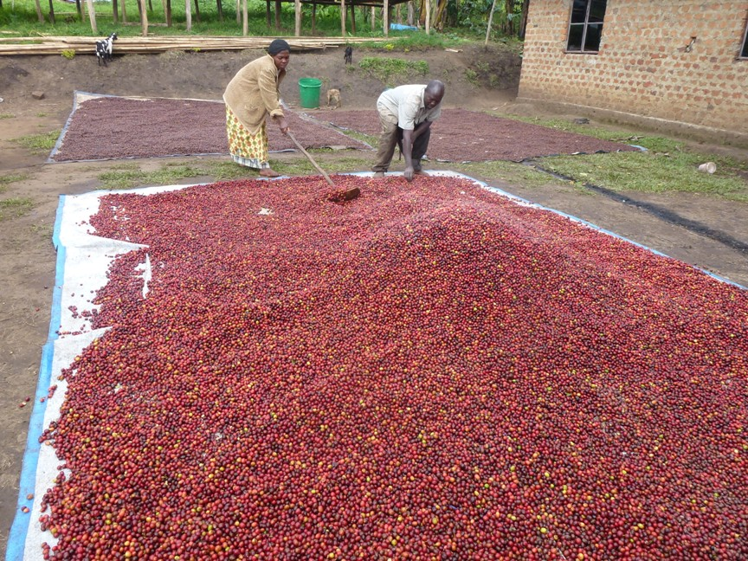
Bikukuru micro-station in Kabarole, Semliki Co-operative, November 2012. Huge volumes of beautiful cherry, nothing to pulp it with, nowhere to dry it.

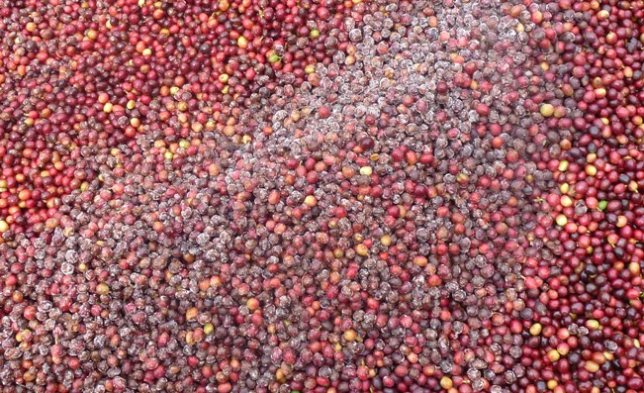
Bikukuru microstation. Beautiful cherry gone mouldy.

It's difficult to know what hard conclusions to draw from the shattering experience at Semliki. Trust is necessary for development to work. You can't work with a farmer organisation successfully if your approach is one of constant suspicion of their motives. I suppose one should not assume honesty from the outset, but should be aware that there are "staged" projects. My mistake was to go along for too long when certain basic things did not happen, such as the full distribution of materials and the deployment of the pulpers. They were warning signs that all was not right, but I did not react, except on the quality issues which resulted from them. It did not occur to me that the manager had other plans for those resources, I thought he was being inefficient and not understanding the importance of having the right tools. At least the farmers were paid for their coffee.

It is a shame. As can be seen from the photos, the quality of the coffee in Kabarole is good, and the farmers were committed to the project. There should be a good farmer organisation operating there, but currently there is not one that I know of.

DRC
In DRC there are four co-operatives under the VECO project, which are widely dispersed, from Idjwi Island in Lac Kivu close to Rwanda in the south, (CPNCK) to Ituri Province opposite West Nile in Uganda, 800km to the north (Kawa Maber). Between them they have built 98 microstations since 2013, and are currently constructing another 34.

The groups in DRC are bigger than in Rwenzori, and the microstations are therefore also larger. BJCU had not yet come up with its later innovations of tiered drying tables and rigid roofs, so we made many of the same mistakes in DRC in 2013 as in Uganda in 2012, resulting in roof failures and larger-than-necessary drying sheds. All new roofs are metal in DRC now, (there is not yet enough money for rigid plastic) and all tables are at least 2-tier. The new metal roofs are not wonderful. They work well in hot weather but in heavy overcast or wet weather the coffee hardly dries. No sunlight at all gets to the coffee unless it is put out on tarpaulins, which is labour intensive, defeating the object of covered drying tables. 2015 was a very wet season, and coffee took much too long to dry under the metal roofs. But they were better than no roofs.

Ventilation gaps at the roof peaks allowed driving rain to blow in on the coffee, and there was some evidence of mould, although not as much as expected. But if you close the ventilation gap, the air does not circulate and any evaporation which condenses on the underside of the roof will rain down again on the coffee. So, we still have not finally solved every problem. The ideal solution would be something like a flower polytunnel such as they use in Kenya, with a ventilation slot along the peak of the roof which can be closed in wet weather. But these are expensive, require flat ground, and cannot be made by farmers, so they do not lend themselves to the model in its pure form.

What we got largely right in DRC is quality, as also with BJCU and West Nile. Not across the board, but at three of the four co-ops. The fourth (Kawa Kanzururu) is a little like BOCU, it does not seem to fully understand what it is doing. Specialty buyers came in immediately with good prices (up to USD 0.60 over New York for uncertified coffee) and continue to support the co-ops. A concerted marketing effort might have made an even bigger impact, but marketing was not prioritised by VECO in the project activities.

At Kawa Maber, the only one of the four DRC co-ops adopted by Twin to date, there has been a problem with volumes. This is partly the late arrival of pre-finance and partly quality issues on two arrival lots in the 2015 season coffee, which discouraged the buyer, Atlas, from issuing a new contract for the 2016 season. These quality issues are currently under investigation. It is strange, since the work done on the Kawa Maber microstations has been mostly excellent (see my visit reports Oct & Dec 2015). This is borne out by the offer sample scores for the 2015 coffee, between 87 and 87.5. The pre-shipment samples for the same lots were between 84.75 and 85.5, (which was borderline from the Atlas perspective), and the arrival samples were between 82.75 and 87.5, which ranged from unacceptable to excellent. Something is going wrong with some of the coffee between leaving the microstation and arrival at destination. This will be investigated further.

But even when there was a contract volumes were low. It was not clear why this was. Members were selling much of their coffee outside the microstation, even though the microstation price was competitive in 2015. This has not been explained satisfactorily.

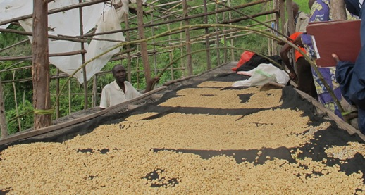
Kighutu microstation, Kawa Kanzururu Co-operative, Rwenzori region, DRC. Erecting ad-hoc table covers in very adverse weather conditions, after UPVC roof sheeting was destroyed by wind and heavy El Niňo rains, late 2015.

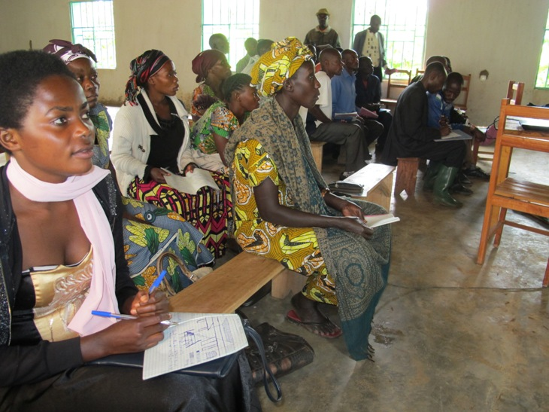
Season planning workshop at CPNCK, Idjwi Island, November 2015

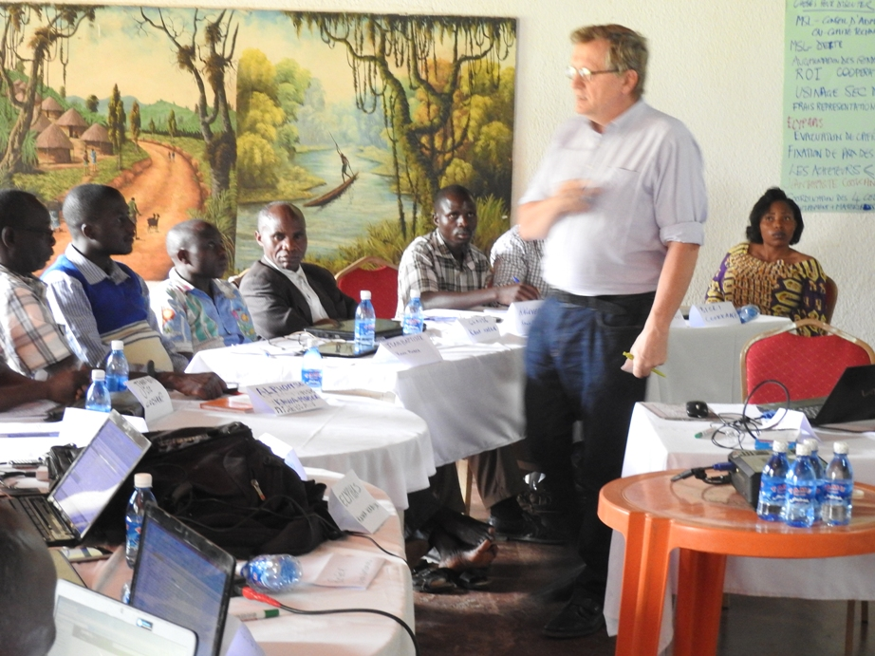
Ivan Godfroid of VECO RDC training managers, accountants and chairpersons of 4 VECO co-ops in risk management, Butembo, April 2016.

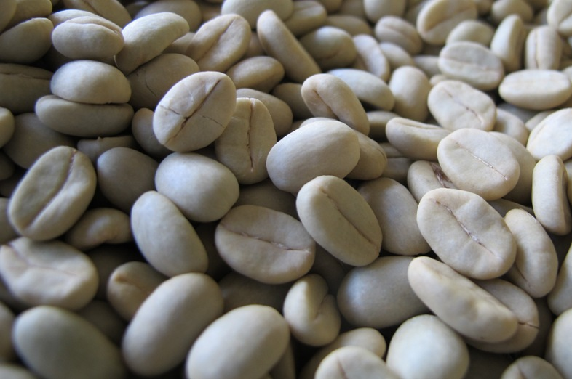
Parchment at Afoyo microstation, Kawa Maber, Oct 2015

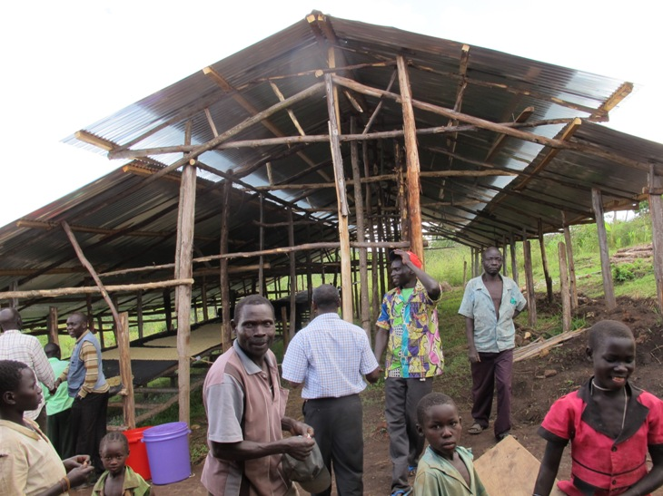
Metal roof of unfinished drying shed at Afoyo, Oct 2015.

Something went wrong at Hutwe microstation, Kawa Kabuya Co-operative, in North Kivu: the microstation members took a short-cut. Instead of contributing the labour, cash and materials from their own resources, they borrowed USD 10,000 from a local private microfinance institution and built a beautiful microstation using a contractor. They bargained on receiving a "second payment" from the co-operative, to repay the loan plus interest. The coffee price went down between buying cherry and signing the sales contract, and the business broke even. There was no second payment, and the debt could not be repaid. The MFI took over the microstation and it now belongs to them, not to the group members. Moral: Don't take short-cuts; to succeed you must follow the model!

West Nile
The model was refined at West Nile in 2015 to include tarpaulins, and the construction was more uniform than elsewhere, benefiting from a tight plan and regular supervision. Even so, there were issues. Details are in my monthly reports 1 to 6, July to December 2015.

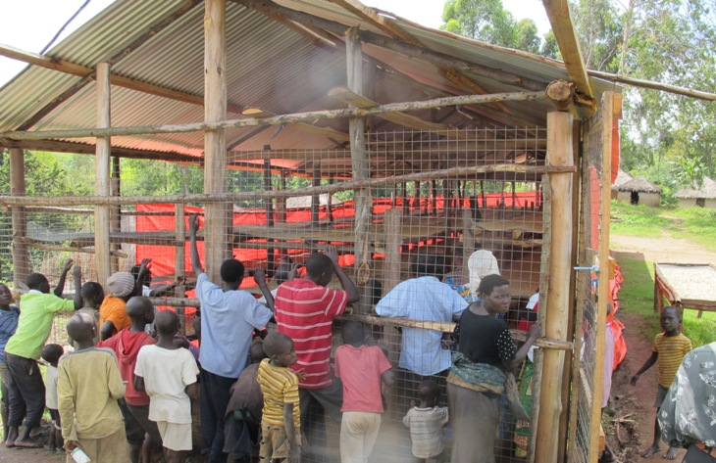
Drying shed at Pamitu microstation, showing 3-tier tables and all-metal roof. Cheaper but not as effective.

The current situation
In late 2016 there are over 160 micro-stations operating in Uganda and eastern DRC, with more under construction and more planned. The figures in the table below do not include a number of private micro-stations which have been constructed in Rwenzori since 2012, with support from BTC and others, which are not part of a co-operative. There are also two farmer-owned micro-stations in Kabarole, northern Rwenzori, assisted by Lutheran World Relief.

Microstation numbers | Operating in late 2016 | Under construction | Constructed but not operating
Uganda
BJCU | 32 |  | 3
BOCU | 25 |  |  | estimate
ACPCU |  |  | 7
Semliki |  |  | 10
West Nile | 2 |  | 1
 | 59 |  | 21
DRC
Kawa Kabuya | 45 | 27
Kawa Maber | 30
Kawa Kanzururu | 16 | 2
CPNCK (Kawa Kendja) | 7 | 5
 | 98 | 34
Totals | 157 | 34 | 21

Some success factors
- It is essential to be clear with farmers about responsibilities ahead of time, and to stick to agreements. The concept must be clear and make sense to farmers. Time taken explaining how the project works is never wasted.
- Do not distribute equipment and materials to microstations until the farmers have met their commitments and the microstation framework is fully in place. There is a tendency for people to do half the necessary work, get enough equipment and materials from the project to begin processing cherry, then never finish the construction job, because they now have too much to do on the processing. If they have to wait a season because they did not finish construction in time, too bad. The project must follow its rules.
- The way farmers currently process coffee must be below optimal, or you will not be able to cover your costs of investment with profits from increased quality. (Part of the reason for Gumutindo's difficulties is that farm-washed coffee on Mt Elgon is historically of high quality and the quality/price increase from central washing struggles to meet the additional cost.)
- It is necessary to have high and dependable quality in commercial volumes. For volume and quality together it is essential to always have enough cash and offer a good price. This sounds obvious but it is not easy to arrange.
- In the early seasons it is necessary to have access to a working capital fund, as it is difficult to get contracts, and therefore crop finance, before the organisation has established a reputation for quality. Rabobank provided working capital at risk in the Twin project 2012-14. Without it BJCU would not have succeeded in the way it has. It is not easy to get this kind of money, but without it failure is very likely.
- Attention to detail is essential in specialty coffee. This does not come naturally to farmers who have been getting no price differential for quality. It requires significant initial training, several repeat trainings, and strict monitoring, going forward. No-one must relax once a good score has been achieved once. Farmers must change their way of thinking about coffee.
- The coffee must be good enough intrinsically to achieve high scores (minimum above 84, preferably 86 and upwards for the really good prices and a solid reputation as a desirable coffee). If the coffee can't get that high, the investment may not be worthwhile.
- Intensive marketing support is an essential ingredient. As well as liking the coffee buyers must get the story, come to visit, talk to the farmers directly, and have a trusted expert that they can call at any time to troubleshoot any contract issues.

It's worth reflecting that about 10,000 farmers have become involved in microstation groups in the five years since 2012, and that these farmers have between them voluntarily contributed somewhere in the region of USD one million of their land, labour, materials and cash, which is about USD 100 per farmer on average. This represents up to 20% of their average annual income. The model has been very strongly supported by farmers, for reasons which are based on expected financial rewards, but which are more complex than just economic self-interest. Many farmers express great pride at the quality of the coffee they now produce compared to what they used to produce, and are equally proud to welcome visitors to their microstations, something that had previously never happened to them.

Analysis of historic cup scores
To be added

